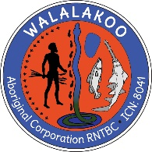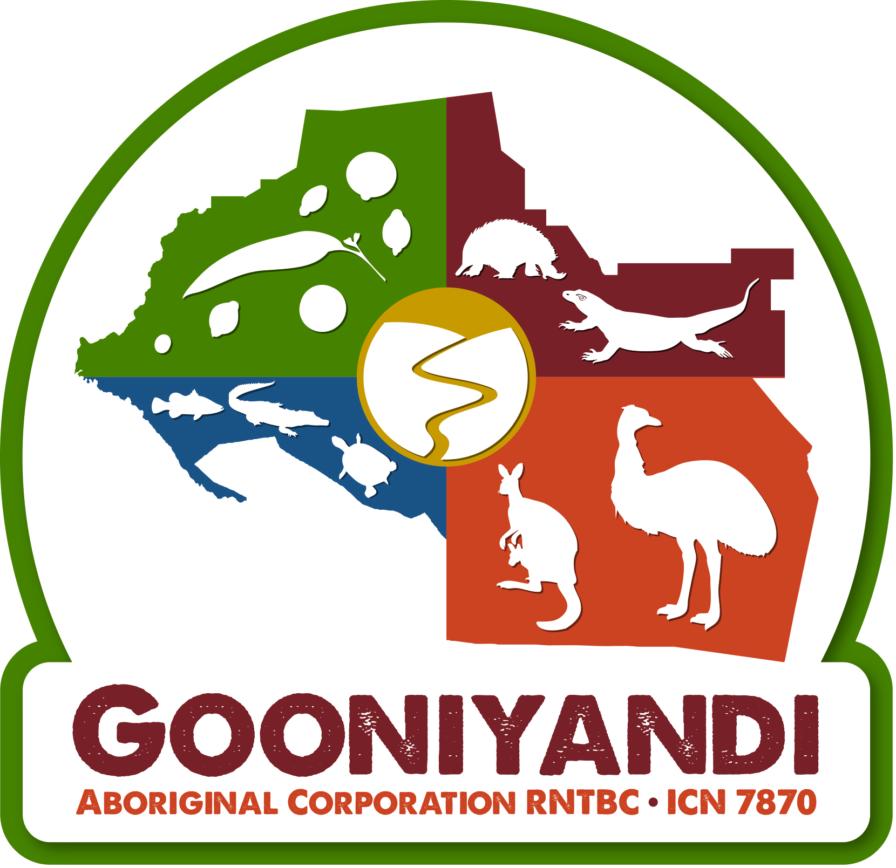

Monday, 14 November 2016

Kimberley Traditional Owners unite for the Fitzroy River

In response to increasing development pressure, Kimberley Traditional Owners have pledged to work together to protect and manage the Fitzroy River and its tributaries, one of the most iconic wild rivers in Western Australia.

During a two-day meeting in Fitzroy Crossing, Traditional Owners agreed upon a Fitzroy River Declaration, aiming to protect the traditional and environmental values that underpin the river’s National Heritage Listing.

The historic declaration identifies eight key steps that Traditional Owners agree are needed to protect and manage the Fitzroy River, including a buffer zone for development, a joint position on fracking, development of a Fitzroy River management plan complemented by an Indigenous Protected Area, and a management body for the river.

Walmajarri Traditional Owner and Yanunijarra Aboriginal Corporation Chief Executive Officer Peter Murray said the declaration aims to address concerns of Traditional Owners regarding extensive development proposals currently facing the river and its catchment.

“We know that there are pressures from industry and government to access and use the Fitzroy River, and these pressures have the ability to impact on its many cultural and environmental values,” Mr Murray said.

“We are also concerned that the cumulative impacts of development along the river will not be managed or considered appropriately by the Western Australian Government.

“The Fitzroy River is one living system. The river gives life and has a right to life, and we are determined to protect it for current and future generations.”

Bunuba Traditional Owner Keith Bedford said the declaration demonstrates that native title rights of Traditional Owners are central to the ongoing management and protection of the entire Fitzroy catchment.

"As native title holders and claimants, Kimberley Aboriginal people respect each other’s autonomy, but we are also committed to working together to better manage and look after the river system,” Mr Bedford said.
Nyikina Mangala Traditional Owner Dr Anne Poelina said the Fitzroy River Declaration sends a clear message to government and industry that Traditional Owners are prepared to stand together for the future of this globally unique living water system.

“We want to see the Fitzroy River and catchment protected all the way from its head to its tail, and we will work together to make sure there are strong measures in place that achieve this goal.

“We invite industry, government, and other stakeholders to work with us in achieving this outcome.”

In 2011 the entire Fitzroy River catchment was added to the National Heritage Listing by the Australian Government because of its exceptional natural and cultural value to the nation, joining other iconic sites such as Uluru and Purnululu National Park. The Fitzroy River is also listed as an Aboriginal Heritage Site under the Western Australian Aboriginal Heritage Act.

The Fitzroy River Declaration sets a national standard for native title rights and the role of Traditional Owners as fundamental to the management of the environment and informed decision making about development.

